**Setting up account on Github**

To complete this tutorial, you will need a GitHub account. Make sure you have an internet connection too!

1. Open GitHub website by clicking on the given link: <https://github.com/>
2. Click on **Sign up** button on the upper right corner of the homepage.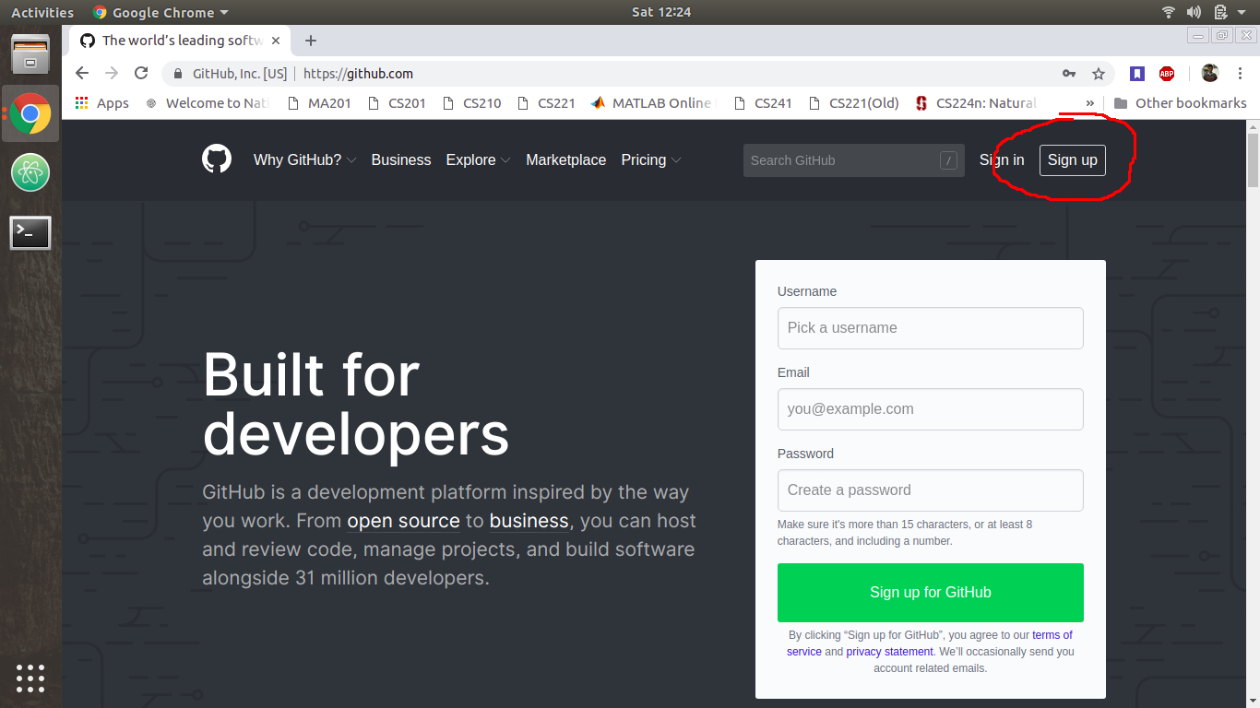
3. Fill your valid credentials and solve the puzzle (will not be too hard :P) and click on **Create an account**
4. GitHub provides **Student Developer Pack** to students which allows you to create private repositories. You can also continue with the **Free** plan. The following steps are given to claim the former. Select **Student Developer Pack** under the **Developer** plan

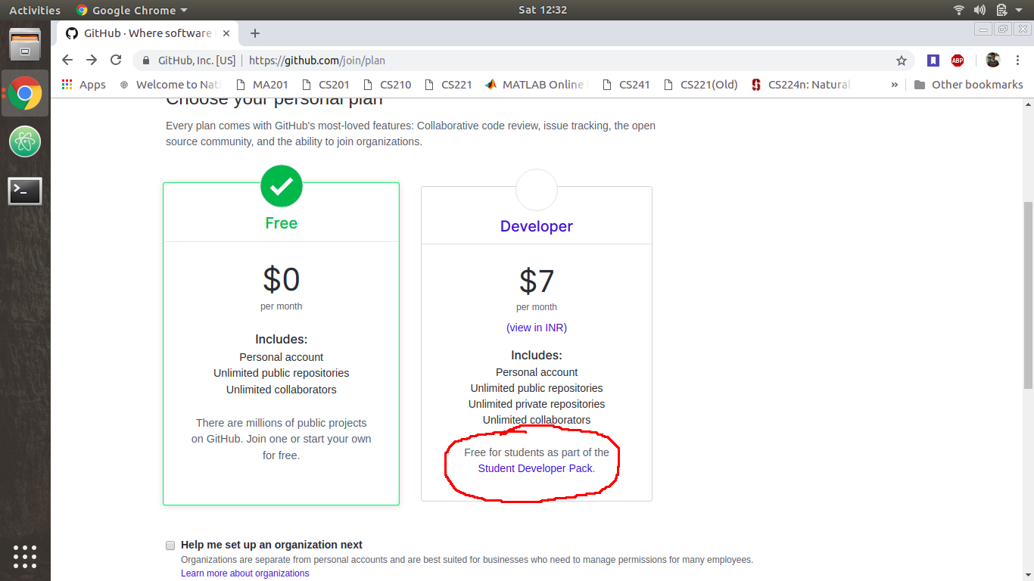

1. Select **Get your Pack** and then **Yes, I’m a student** when each of the new windows open.
2. Specify your **webmail ID** (e.g. xxxxxxxxx@iitg.ac.in) in the email address field. Verify your webmail ID by logging into your Outlook account in a new tab and clicking on the verification link. If the verification email is not received by your account, click on **your Github email settings.**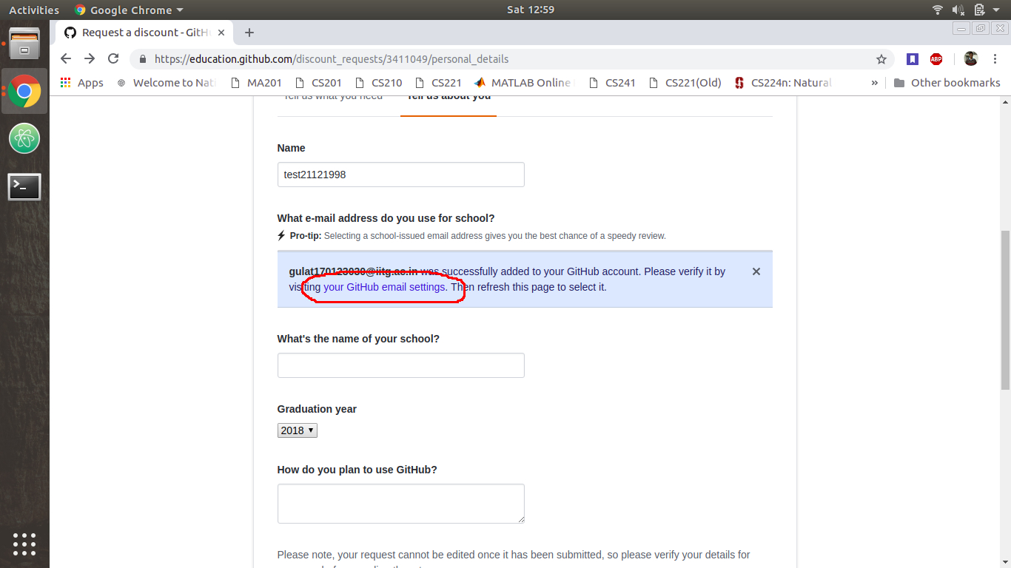
3. Click on **Resend** button next to your webmail ID and follow the above step for email verification.
4. Once your email has been verified, go back to the page mentioned in step 6 (and shown in the above screenshot) and refresh the page. Your webmail ID will appear as a button with your college name (IIT Guwahati) mentioned alongside. Select your webmail ID and fill the rest of the credentials, and click on **Submit request.**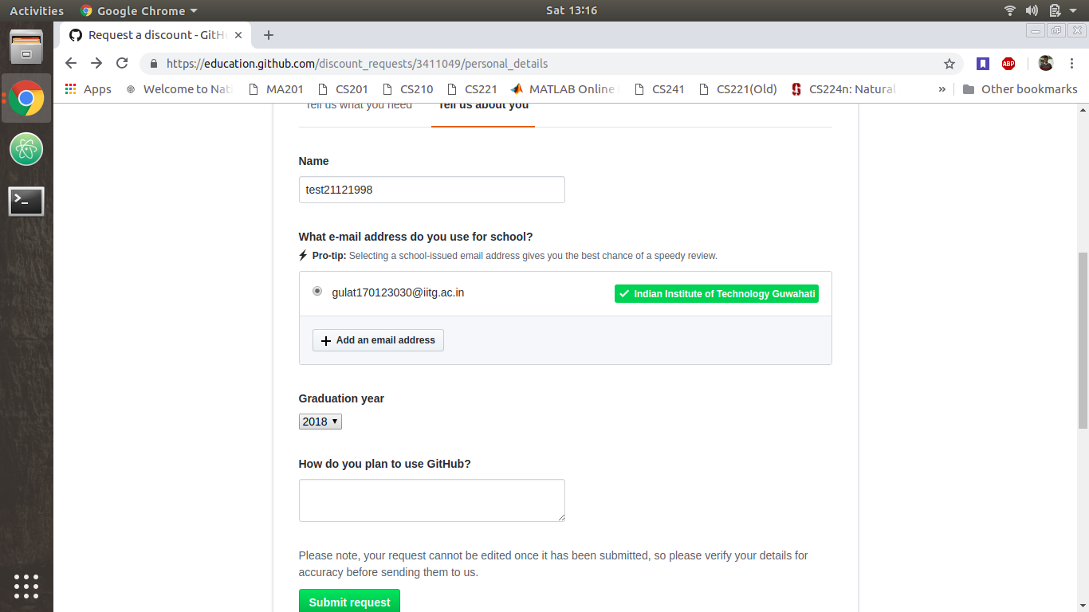
5. You will be redirected to a page mentioning the process has been successful. You will also receive a mail about the upgradation of your pack. Go back to the homepage (<https://github.com/>) and log into your account.

